Berry Springs Primary School Community
working to create a centre of educational excellence, developing students who are lifelong learners and active contributors to society.

Berry Springs Primary School
Teaching and Learning Guidelines
This document was developed by the staff of Berry Springs Primary School

Version Control
School Council Approval | August 2018

Contents
Rationale 3
Purpose 3
Our Commitment: 3
Curriculum Structure 3

Rationale
At Berry Springs School we believe every child is to be given the opportunity to reach their potential, achieve academic excellence through access to curriculum and learning environments that reflects our vision, values and beliefs about children’s learning.
Whole school Approaches It reflects the School Vision and Values as well as the current Strategic Plan.

Purpose
The Berry Springs School Teaching and Learning Guidelines provide guidance and detailed information to teachers and other Berry Springs School Staff to Plan, Program, Teach Assess and Report in order to deliver the highest quality of education facilitate the learning and development of Berry Springs School students.

Our Commitment:
Belonging
All students, staff and parents: work together in a mutually supportive way with a strong sense of belonging and pride in the school.
Accountability
All students, staff and parents will operate consistently within our values and communicate regularly in a clear, timely and effective manner.

- Our Values:
- Dignity: All students, staff and parents inspire the quality of behaviour that reflects the honour and dignity of each person.
- Respect: All students, staff and parents engage purposefully in honest, open dialogue to maintain a strong supportive culture.
- Integrity: All students, staff and parents interactions focussed on the learning and well-being of all and improving the school’s ability to meet the needs of all students.
- Trust All students, staff and parents have an overt shared commitment to the improvement of teaching and an openness to feedback by peers and colleagues

Curriculum Structure
Berry Springs School systemically delivers the Australian Curriculum underpinned by the Schools Scope and Sequence. Teachers in partnership with the leadership team support the teaching of Australian Curriculum Achievement Standards and are expected to work within the ATSIL Standards.

Berry Springs School implements the
- Australian Curriculum (T- Year 6)
- Nt Presschool Curriculum
- The Northern Territory Multi-level Scope and Sequence (T- Year 6)
- The Early Years Learning Framework for Australia (P- T)

Berry Springs Curriculum Map Appendix A

- Principals and Approaches to Teaching and Learning
Berry Springs Primary School implements the Northern Territory Department of Education Framework for Curriculum, Pedagogy, Assessment and Reporting for T – 9 Students. This document provides teachers with an overview of time allocations for subjects, teaching pedagogies and a framework for planning, teaching and assessing. It also provides a summary of Departmental expectations around expected assessments.
Berry Springs Primary School has a focus on Visible Learning, Growth Mindsets and The 5 Keys:
- Persistence
- Resilience
- Organisation
- Getting Along
- Confidence
- Assessment & Reporting
Teachers will plan authentic and consistent assessment tasks as a vital part of the teaching learning cycle. Formative assessment will be used to inform teaching and learning cycles and summative assessment will support the overall progress of students. Whole school assessment guidelines and schedule are used to inform teachers of the expectations and sort s of assessments required.

Whole school assessment schedule Appendix B (needs link)

Reporting
Reporting to families occurs at the end of each semester. Reporting is made for all subjects areas taught, with English and Maths being compulsory each semester. A-E grades, a comment and effort level are recorded on SAIS for each student. Should a student not have enough evidence of learning for a report to be written, an N/A with a comment to support this needs to be placed on SAIS for that student.

Written comments must provide families with information about what their child can do in the subject area as well as what their next steps in learning will be.

- Planning and programming
Our Teachers follow the Planning and Programming guidelines for Teachers Transition – Year 9.

Teachers use a learning design approach which is targeted to what the students have learned and what they need to learn.

Berry Springs School in committed to quality planning and programming and supports collaborative and collegial planning with instructional teams.

Collaborative planning time for each teaching Team is timetabled. Teaching Teams will devote time to: moderate; plan and assess; make observations and provide feedback; participate in professional dialogue and learning.

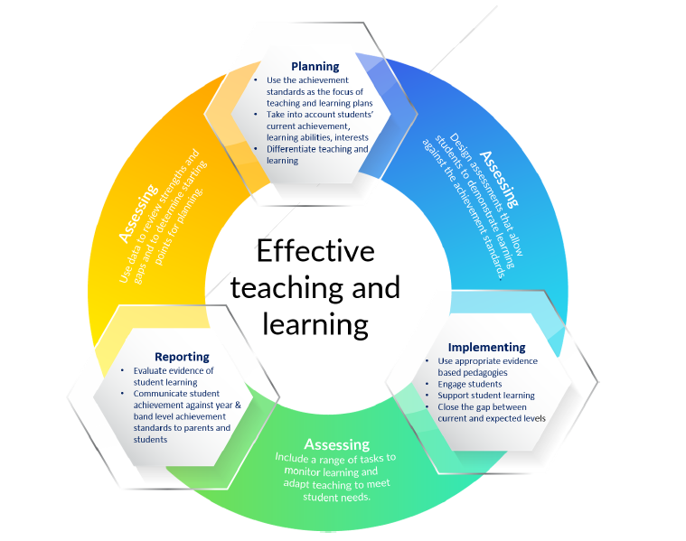

- Responsibilities
Principal | Lead the planning, development, implementation and review of the Berry Springs Teaching and Learning Guidelines
Teaching staff | Plan, Teach and Assess students consistent with the Berry Springs Teaching and Learning Guidelines  Contribute to planning, decision making, implementation and review of the Curriculum Policy and related documents
Parent Rep Body | Contribute to the review of the Berry Springs Teaching and Learning Guidelines  Ratify the Berry Springs Teaching and Learning Guidelines

- Review and Evaluation
The Teaching and Learning guidelines will be reviewed yearly as part of the end of year staff planning process.

- References and related documents

- Australian Curriculum (T- Year 6)
- The Early Years Learning Framework for Australia (P- T)
- A Framework for Quality Education in Northern Territory Schools – Curriculum, Pedagogy, Assessment & Reporting

